

**KENYATTA UNIVERSITY**

**SCHOOL OF PURE AND APPLIED SCIENCES**

**DEPARTMENT OF COMPUTING AND LIBRARY SCIENCES**

**SIT 400: PROJECT PROPOSAL**

**WIKONNECT COLLABORATIVE TEAM MANAGEMENT SYSTEM FOR STUDENTS**

**BRENDAH NYANCHAMA ONSOMBI**

**J31/3605/2021**

**SUPERVISOR: Mr. BENSON OKEBE**

*This proposal is submitted for the purpose of the requirements for the ward of the degree of Bachelor in Information Technology in the School of Pure and Applied Sciences of*

*Kenyatta University*

**DECEMBER 2024**

Figure 1 : Login page 2

Figure 2: student sign up page 3

Figure 3: Lecturer sign up page 4

Figure 4: Lecturer homepage 5

Figure 5: Student homepage 5

Figure 6: Task submission page 6

Figure 7: Student booking appointment page 7

Figure 8: Lecturer appointment schedule page 7

Figure 9: student performance summary 8

Figure 10: Appointment report 9

Figure 11: Logical design for the proposed system 10

Figure 12: Physical design for the proposed system 11

Figure 13: Flow chart for the proposed system 13

Contents

**CHAPTER FIVE** 2

**5.0 SYSTEM DESIGN** 2

**5.1 Introduction** 2

**5.2 Software Architecture** 2

**5.3 Hardware Architecture** 3

**5.4 User Interface Design** 3

**5.4.1 Login page** 3

**5.4.2 Sign up page** 4

**5.4.3 Navigation page** 5

**5.4.4 Analytics page** 7

**5.5 Database Design** 8

**5.5.1 Logical Database Diagram** 8

**5.5.3 Physical Database Design** 9

**5.6 Flow chart diagram** 9

# 

# **CHAPTER FIVE**

# **5.0 SYSTEM DESIGN**

## **5.1 Introduction**

In Chapter 5, it focuses on the crucial phase of system design for our proposed system. This phase serves as the bridge between the requirements identified during the analysis phase and the actual implementation of the system. Within this chapter, we explore key aspects of system design that contribute to the successful realization of the proposed Collaboration management system. It encompasses defining the system architecture which is selecting an appropriate pattern to ensure scalability and performance, database design identifies entities, attributes, and relationships for smooth data storage and retrieval, User interface design which prioritizes intuitive and visually appealing experiences, simplifying task management and collaboration, functional component design outlines module responsibilities using diagrams for seamless information flow. This comprehensive system design phase forms the foundation for development.

## **5.2 Software Architecture**

The proposed system is online platform which aims to facilitate the student and lecturer interaction which is currently a modal feedback model through implementing automated functionalities. The key functionalities include appointment scheduling, progress tracking, feedback management, reminders and notification alerts. The front-end will offer a friendly dashboard for students and lecturers, the back-end ensures secure authentication and efficient API communication. The database manages all data including user roles, tasks and appointments.

## **5.3 Hardware Architecture**

The proposed system is based on a **client-server architecture**, where the application will be hosted on a central server, and clients will access it via the internet on their devices.

The desired operating system for the server and client machines is **Microsoft Windows 10.** The hardware requirements for the environment include a machine with a minimum of **8GB RAM**, a **1.7 GHz processor** and at least **50GB of storage**.

## **5.4 User Interface Design**

### **5.4.1 Login page**

This is the first page users will be interacting with when using the system. A user will be requested to provide username and password, in the case where a wrong password or username is provided an error message will pop up. First time users will be redirected to the registration page based on their roles in the system.

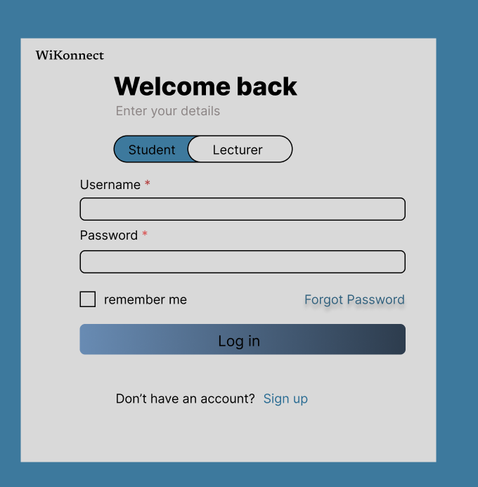

Figure 1 : Login page

### **5.4.2 Sign up page**

This is the registration page for new users of the system.

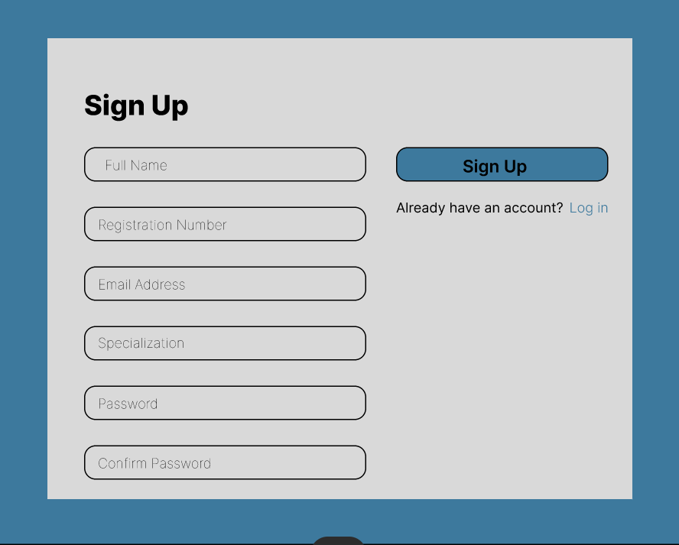

Figure 2: student sign up page

a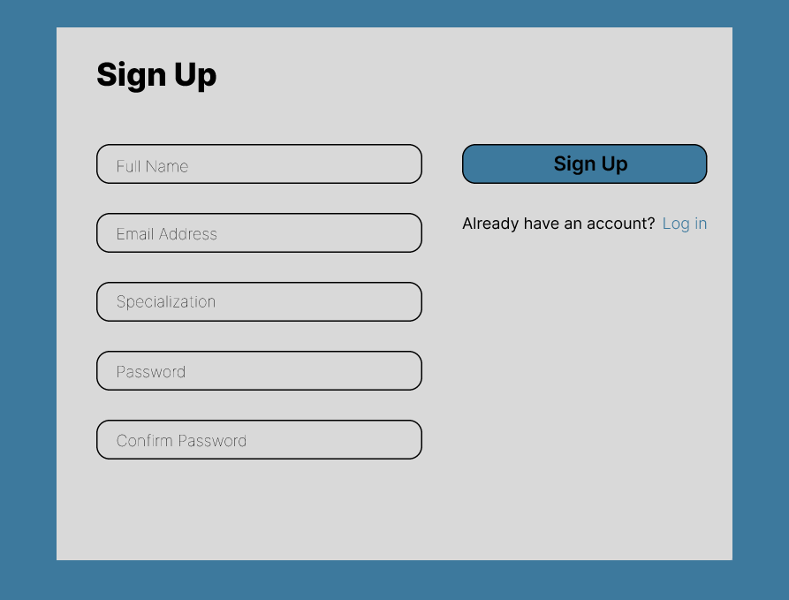

Figure 3: Lecturer sign up page

### **5.4.3 Navigation page**

The navigation dashboard of the system is designed to cater to both lecturers and students. On the lecturer's side, the dashboard displays upcoming events, pending events and student information to facilitate progress tracking and efficient management of schedules and interactions with students. On the student’s page, the dashboard highlights upcoming deadlines, recent feedback and previous activities to ensure the users stays informed in managing their academic tasks and meetings.

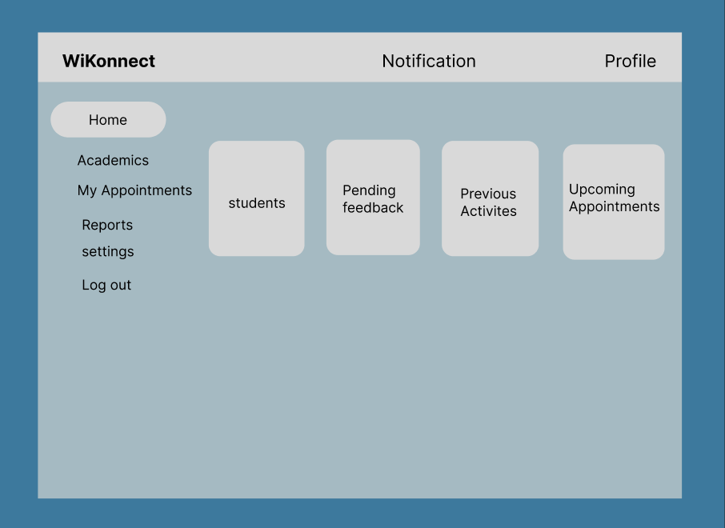

Figure 4: Lecturer homepage

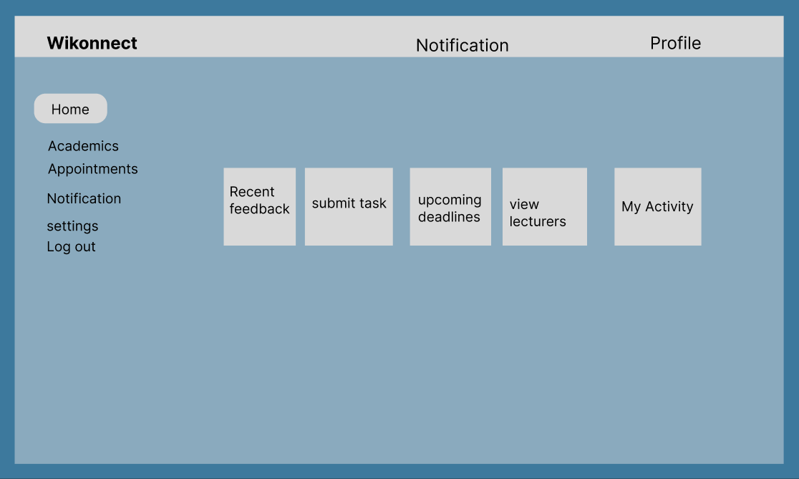

Figure 5: Student homepage

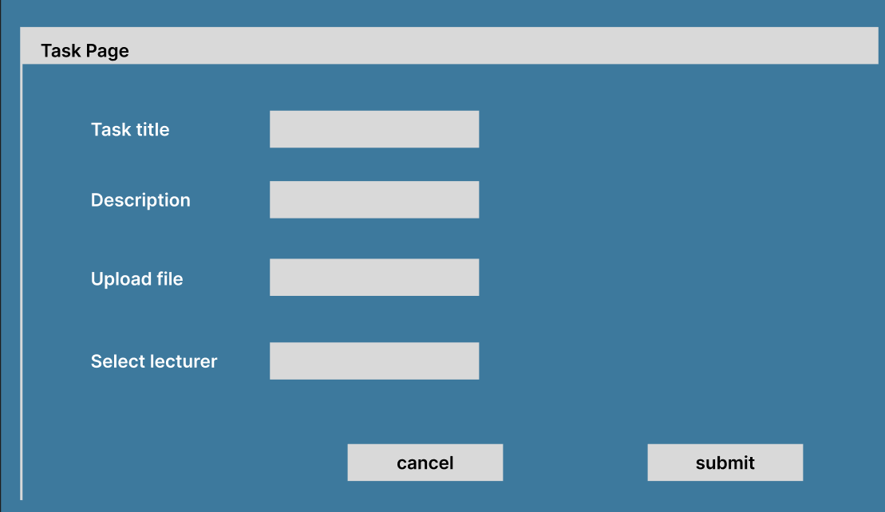

Figure 6: Task submission page

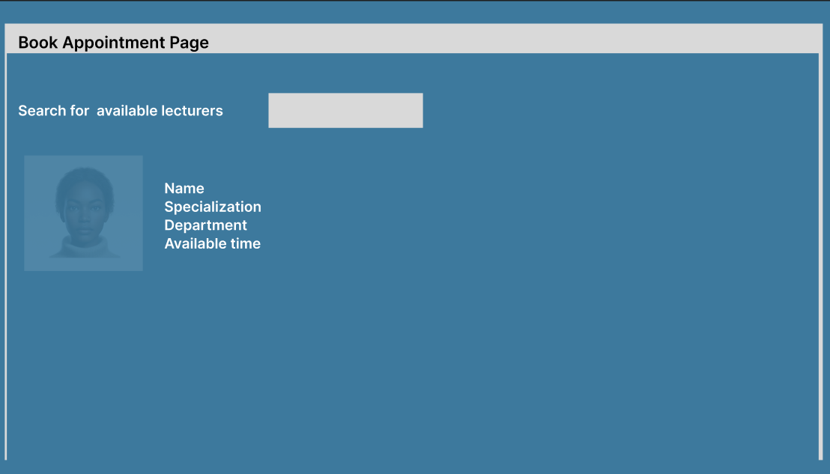

Figure 7: Student booking appointment page

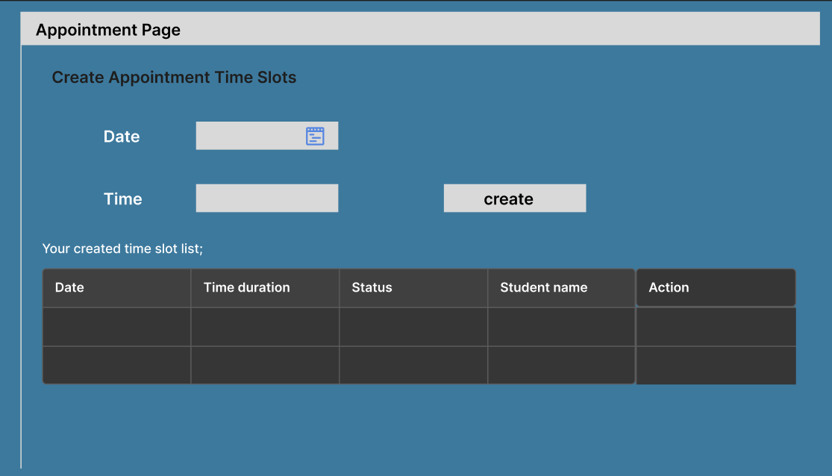

Figure 8: Lecturer appointment schedule page

### **5.4.4 Analytics page**

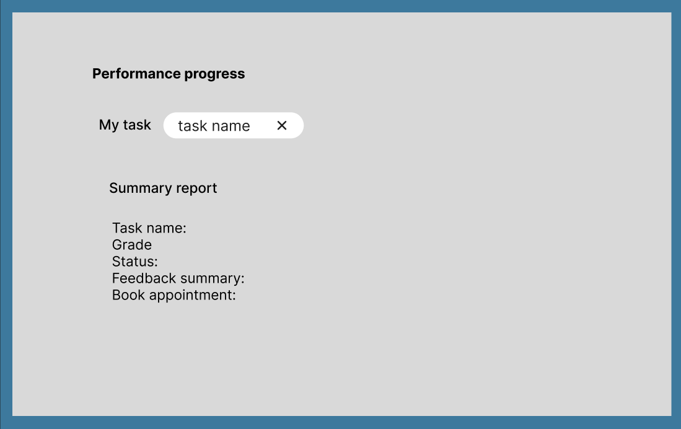

Figure 9: student performance summary

The appointment page report will enable the lecturer to view recent appointment report with information regarding the student who booked the appointment, the reason for the meeting and the time the meeting was scheduled.

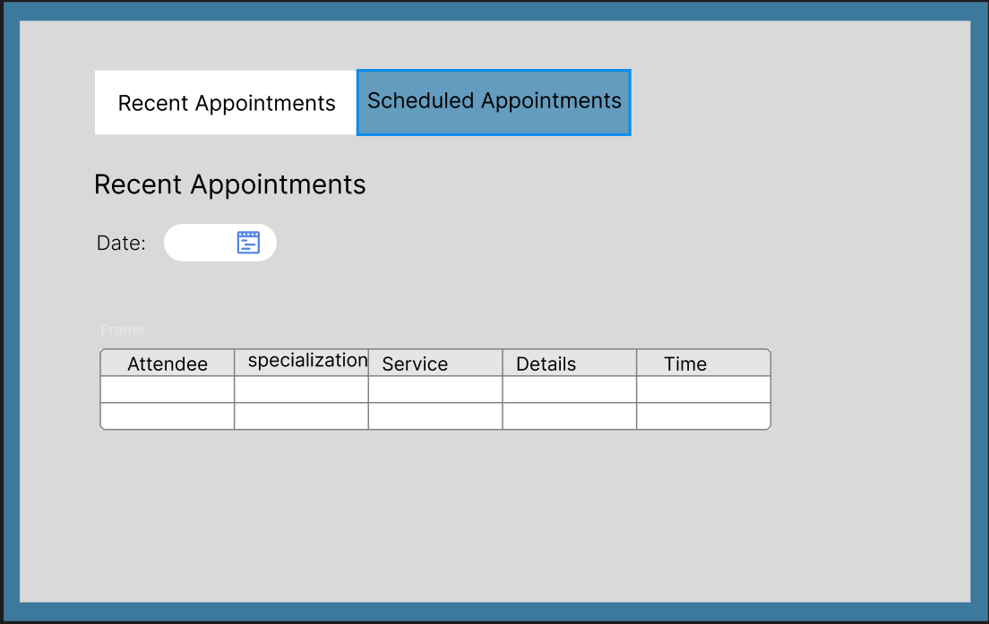

Figure 10: Appointment report

## **5.5 Database Design**

The overall system database comprises of several tables which store data from different operations and users, therefore making information management much easier. Some of the different tables in the system database include login, student, administrator, lecturer, appointments, tasks and reports database tables.

### **5.5.1 Logical Database Diagram**

Entities:

**User**: Represents the system users, including lecturers and students.

**Appointment**: Represents scheduled meetings between users.

**Events**: Represents feedbacks or notifications.

**Message**: Represents communication between users including notifications and feedback.

### 

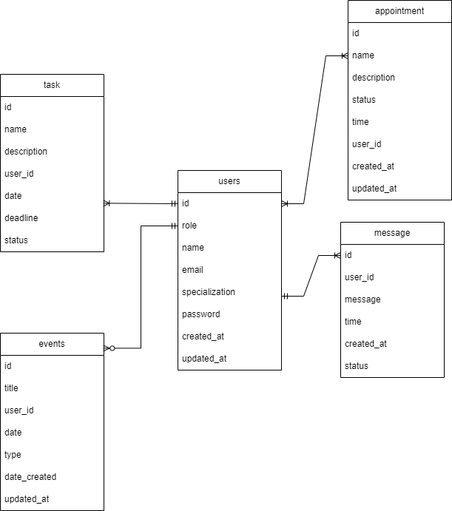

Figure 11: Logical design for the proposed system

### **5.5.3 Physical Database Design**

In the diagram below, the database design has the key entities including user**, Tasks, Appointments, Message** and **Events**. The user collection has roles for student and lecturer, the table serves as the foundation for connecting other entities. Tasks capture student submissions. **Appointments** manage scheduling between students and lecturers, ensuring efficient communication and progress tracking. The **Events** collection provides notifications and deadline tracking to keep users informed. Relationships between these entities are established using unique identifiers (PK).In each table, there is (FK) which references (PK) attribute of an entity from other tables.

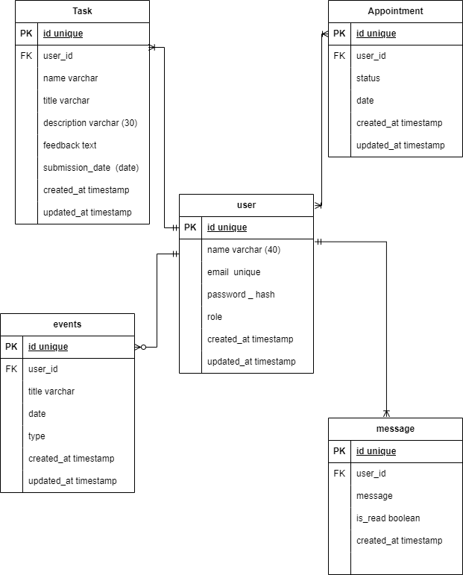

Figure 12: Physical design for the proposed system

## **5.6 Flow chart diagram**

The flowchart below outlines the post-login activities for students and lecturers in the proposed system. After successfully logging in, both users are directed to their respective dashboards. Students can choose from several activities, including submitting tasks, viewing feedback, and booking appointments with lecturers. Each of these activities once completed, the student returns to the dashboard or logs out. Similarly, lecturers can select activities such as reviewing student tasks, viewing student performance analytics, and managing appointments. Once the lecturer is done with the activities in the system, he can log out or return to the dashboard to view more activities. The flowchart uses decision point select to guide users through their options.

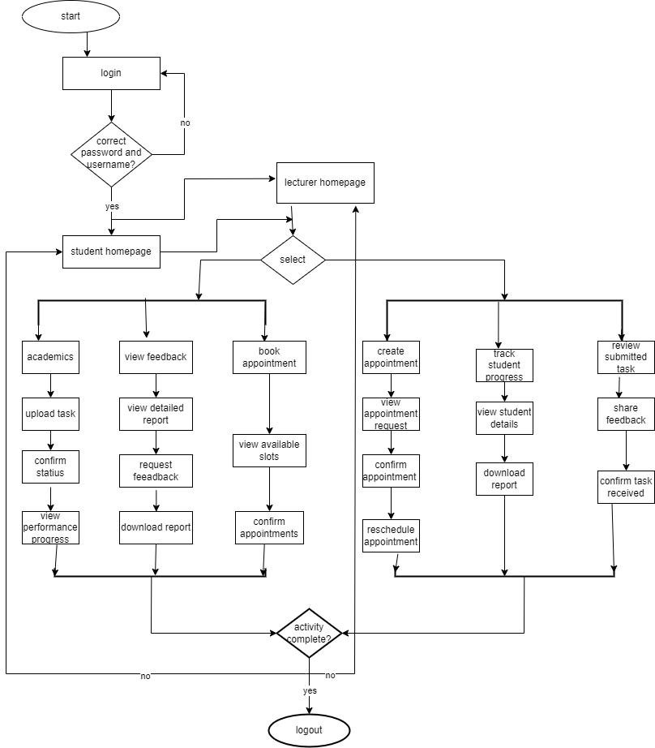

Figure 13: Flow chart for the proposed system